# Introduction

This document lists the installation and deployment requirements.

# Installation Requirements

Software Requirements:

* npm
* pgAdmin
* Command Prompt

Hardware Requirements:

* Windows OS computer
* ~700MB of disk space

# Configurations

## Note:

* The following configuration instructions are for deploying a local development version of the app
* Ideally, once the app’s features are finished, the app should be hosted online for ease of access

## To configure the database:

1. Install pgAdmin and set your password to “password123”
2. If your password is not “password123”:
   1. Navigate to app/server/index.js
   2. At the top of the file, find the password field and set it to your password entered
   3. Navigate to app/server/requests.js and repeat
   4. Ensure that your password is enclosed in quotation marks

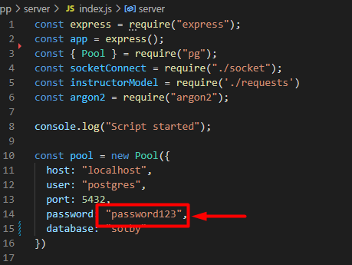

1. Download the db.sql file
2. In the browser tab, right-click on “Databases” and click on “create”

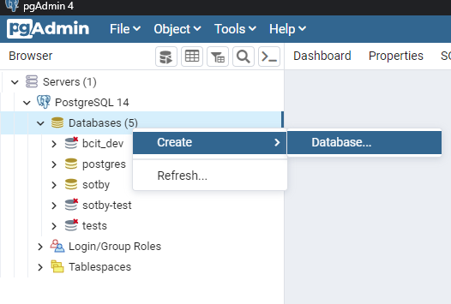

1. Name your database “sotby” and click “save”

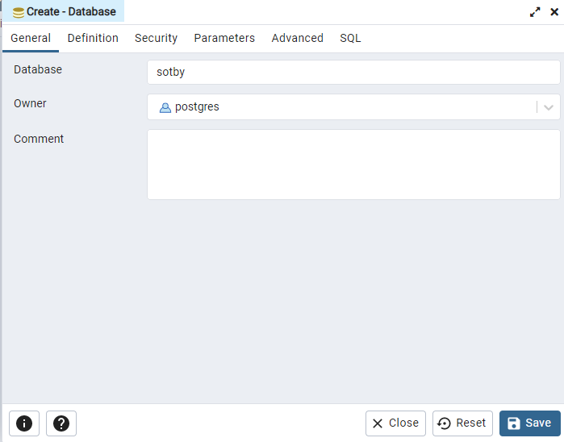

1. Right-click on the “sotby” database and click on “Query tool” to launch it
2. Open your db.sql file in a separate window and drag the file into the query editor
3. Press “F5” or click on the arrow button to create the database tables

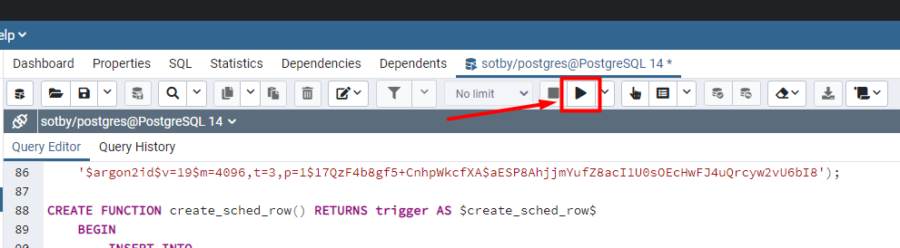

1. Done!

## To configure the app

1. Install the project files for the app
2. Open the folder the project files are in
3. Launch the command prompt
4. Type “cd” and drag the project folder into the command prompt

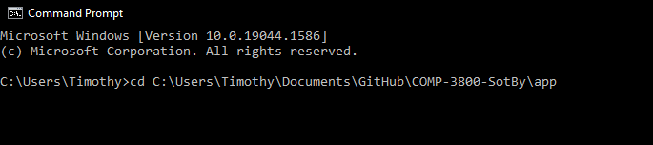

1. Press enter to enter the project folder in the command prompt
2. Type “npm install” and press enter
3. After the installation process has completed, type “cd server” to enter the server folder
4. Press enter and type “npm install” again

### Launch the app

1. Launch the command prompt
2. Type “cd” and drag the “server” folder into the command prompt
3. Type “npm start dev” in the server folder of the app
4. Launch another command prompt
5. Navigate to the “app” folder and type “npm start dev”

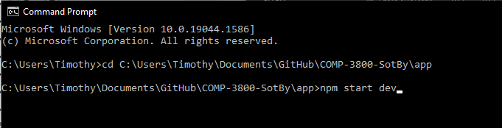

1. A window should be automatically opened for you and you can now run the app!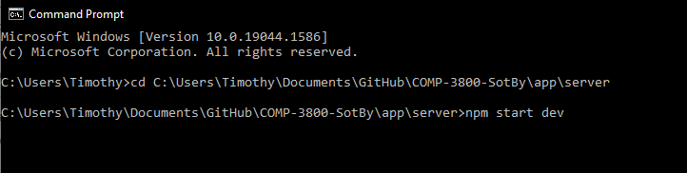

# Final Code

The app’s scripts and files are located in the App folder. The server files are located in the Server folder inside the App folder. The file for creating and configuring the database is named db.sql and should be in the root folder.